**CSC Pathways**

User Manual

Frontend website & Backend CMS

Michael Risher

June 27, 2017

Table of Contents

User Side of the Website 3

Navigating the user side 3

Possible problems 5

Accessing the administration side of the site 5

Problems logging in 6

Recovering a forgotten password 7

Managing Classes 8

Creating classes 8

Fields within the create class 10

Possible problems creating a class 11

Editing classes 11

Editing Classes in Different Languages 12

Deleting classes 12

Managing Certificates 12

Creating certificates 13

Fields within the create certificate 14

Possible Errors 18

Editing certificates 19

Deleting certificates 20

Managing Users 20

Creating users 20

Editing a user 21

Recovering a password for a user 22

Deleting a user 23

# User Side of the Website

The user accessible side of the website consists of one page. From this single page, the user can see a listing of all the certificates available in a tree structure. From this listing, the user can click on any of the certificates to show more details about that specific certification, all while staying on the same page. The details for each certification include a brief description of the program, the expected learning outcome, and an outline of courses they should take and when we offer them. In the outline of courses, they can click on any course to show more details about that course such as the title, a brief description, any prerequisites, advisories, or corequisites, a transfer code if any, and the number of units.

## Navigating the user side

All navigation on the user side are simple. You start with a listing of all the certificates broken into three groups based on what class or classes you need to take. The site also provides the certificate number and total units required to complete the certificate. All the certificates in the listing are colored blue to provide clarity that these can be clicked.

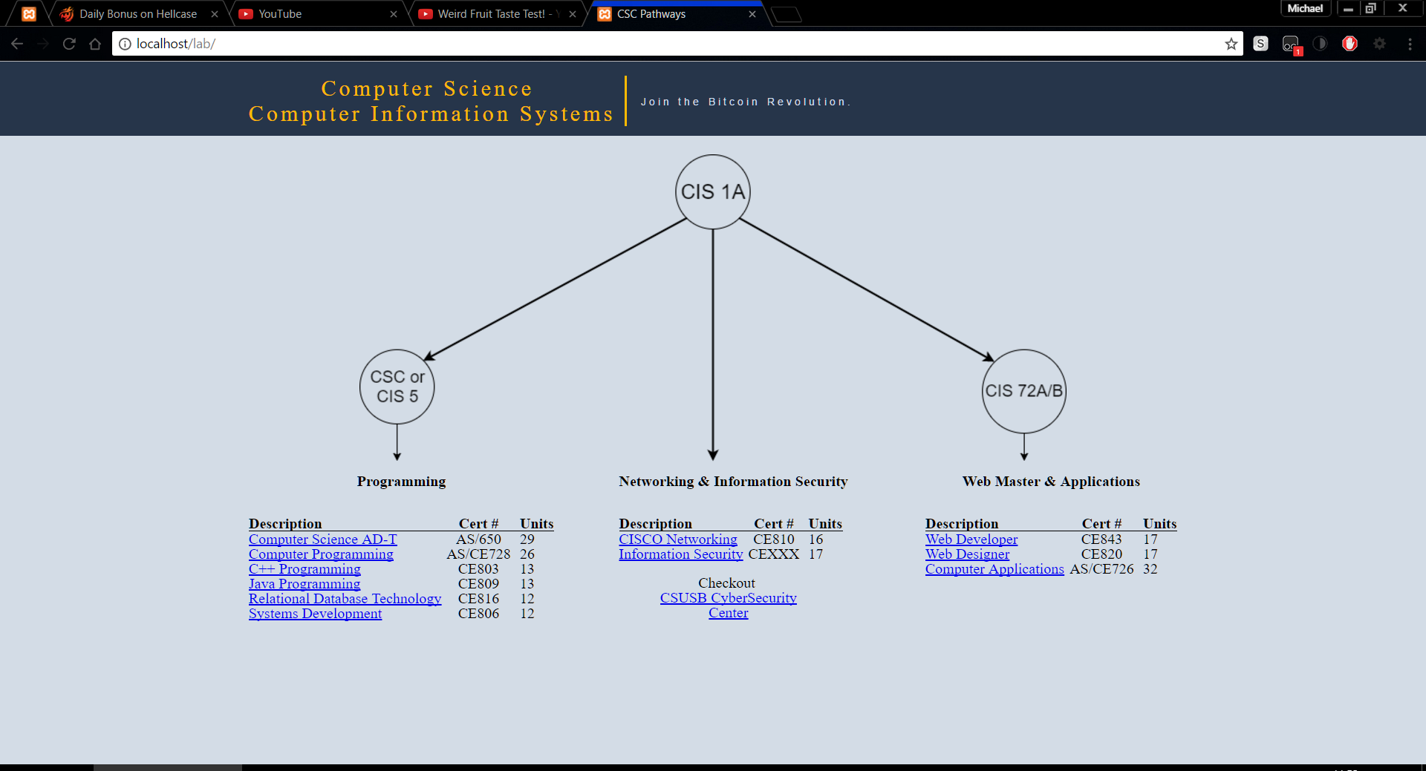

Figure Image of what the user would see

Clicking on any of the blue certificates will request data on the certificate from the server. Once the data on the specific certification loads the page will scroll down to display it. Inside the certificate information it redisplays the certification title along with a brief description of the certificate, a listing of what you are expected to learn by completion of the certification, and a schedule of classes to take and when we offer them. In the schedule of classes that need to be taken each of the classes are linked to display information about that class, they are clearly marked blue to indicate they can be clicked. In the top right corner of the certificate information page there is an up arrow that will go to the top. There is also a tooltip to explain this to users when they hover over it.

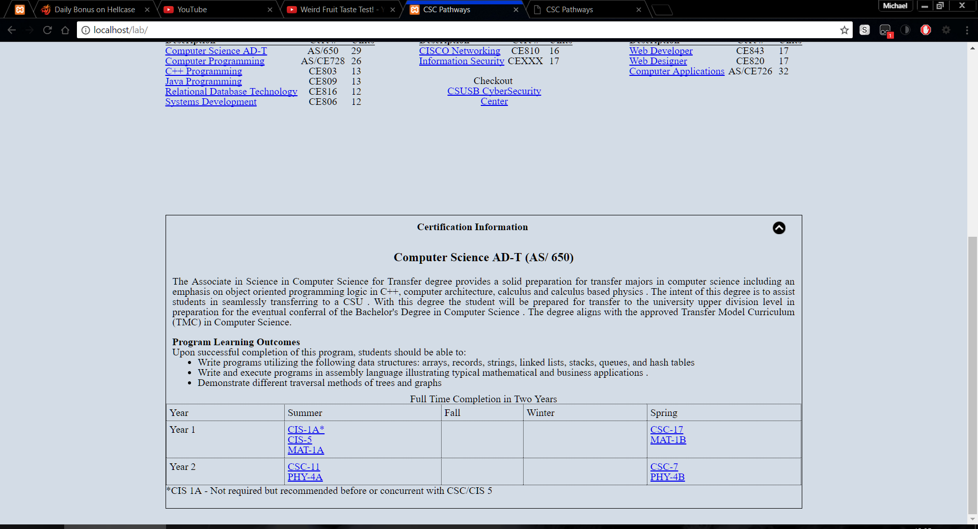

Figure Certificate information as seen by user

After the user clicks on a class the page then loads that class data and displays it below the certificate information. In the class information box, there is the class title, an equivalent transfer code if any, any required classes to take this class, number of units, and a brief description. Like the certification information there is a to top image, however this goes to the certification instead of the top which is noted in a tooltip for the user.

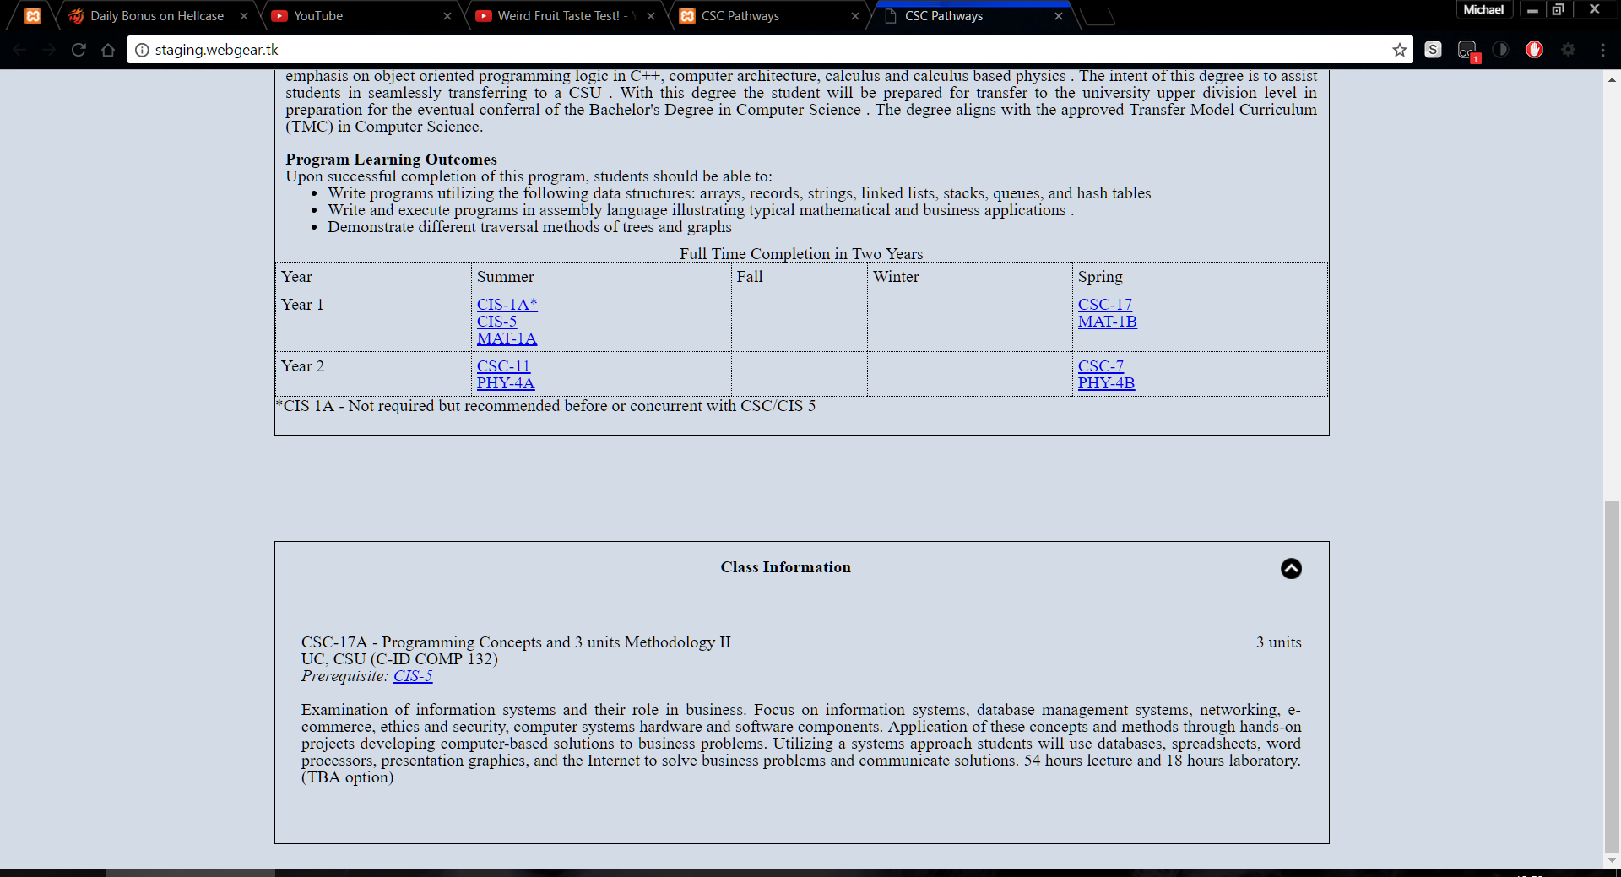

Figure Class information as seen by the user

### Possible problems

The users could have a few problems. They would mostly be related to interrupted internet connections or a slow connection. If a user has a slow connection they would see a loading icon (Figure 4). If a user’s internet was interrupted the certificate or class information would fail to load and would then display that it failed to load (Figure 5). The errors can usually be resolved by reloading the page.

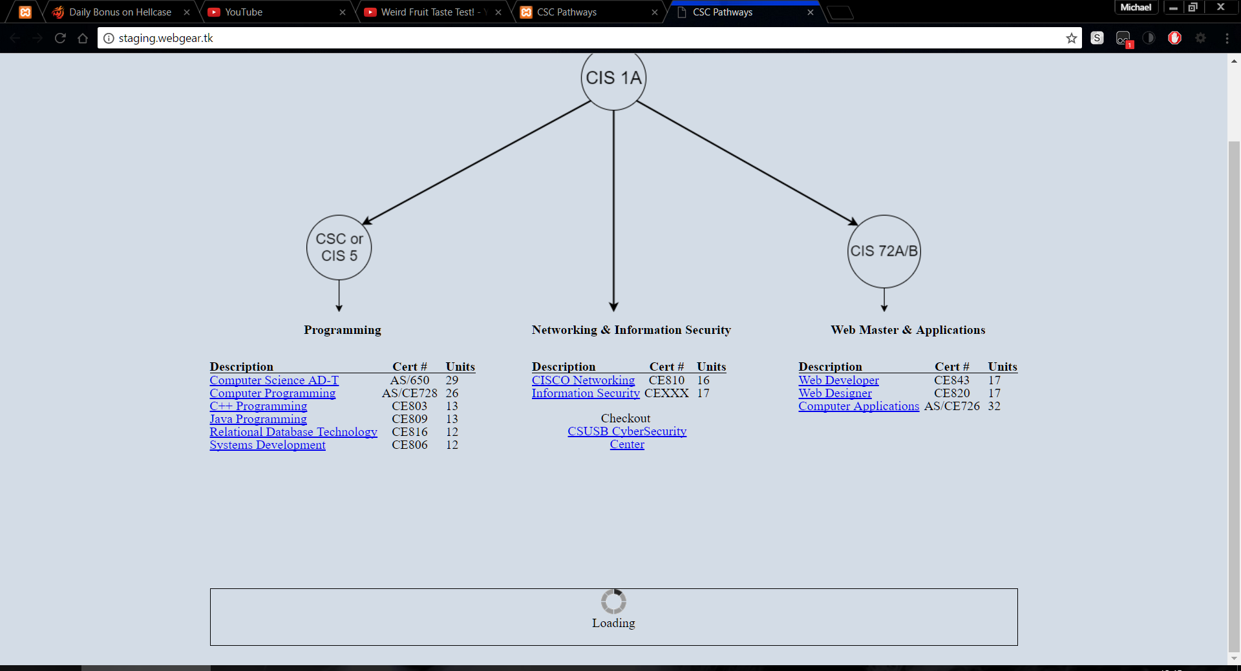

Figure Displaying a slow internet

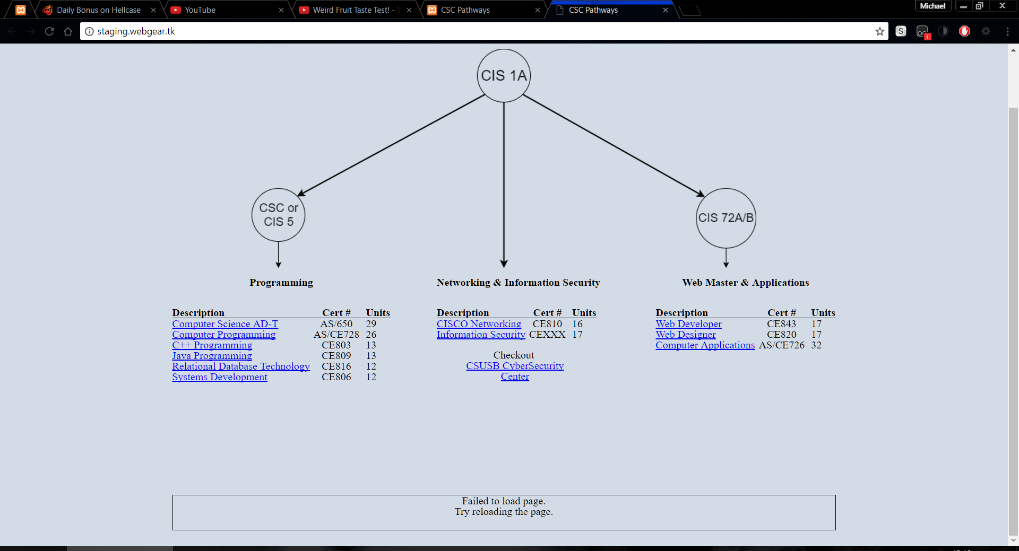

Figure Displaying a failure to load error

# Accessing the administration side of the site

For security reasons, there is no public link to the administration side of the site. The link to the site is <http://cscpathways.us/login>. When you load the page, you will be presented with a form that has a field for a username and password.

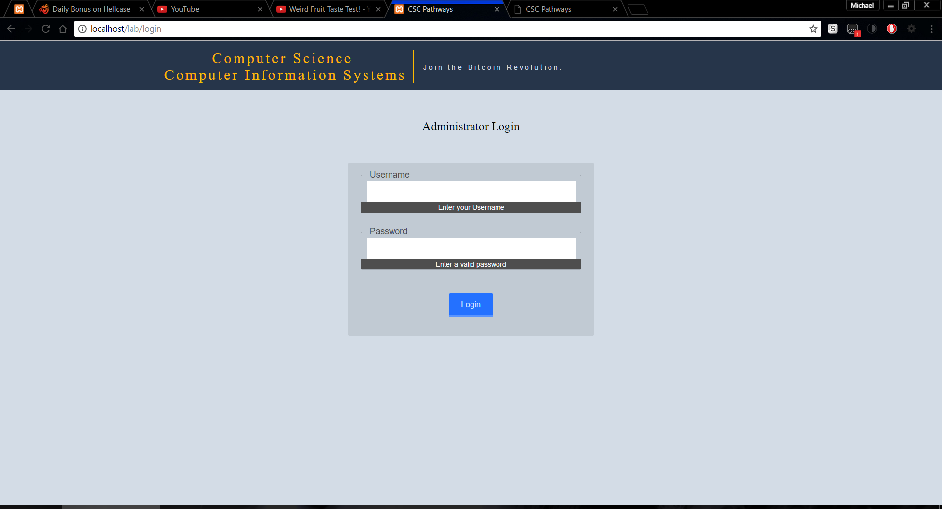

Figure The administration log in page

To log in enter your correct username and password. After a successful log in you will be redirected to the admin homepage. In the admin homepage, you can click the orange title at the top of the page to get back to the user side of the site. Just below the orange line are links to go to the admin home (the page you are on currently), manage classes, manage certificates, manage users (if the current user has the rights to), and on the far right there is a link to logout of the administrative side.

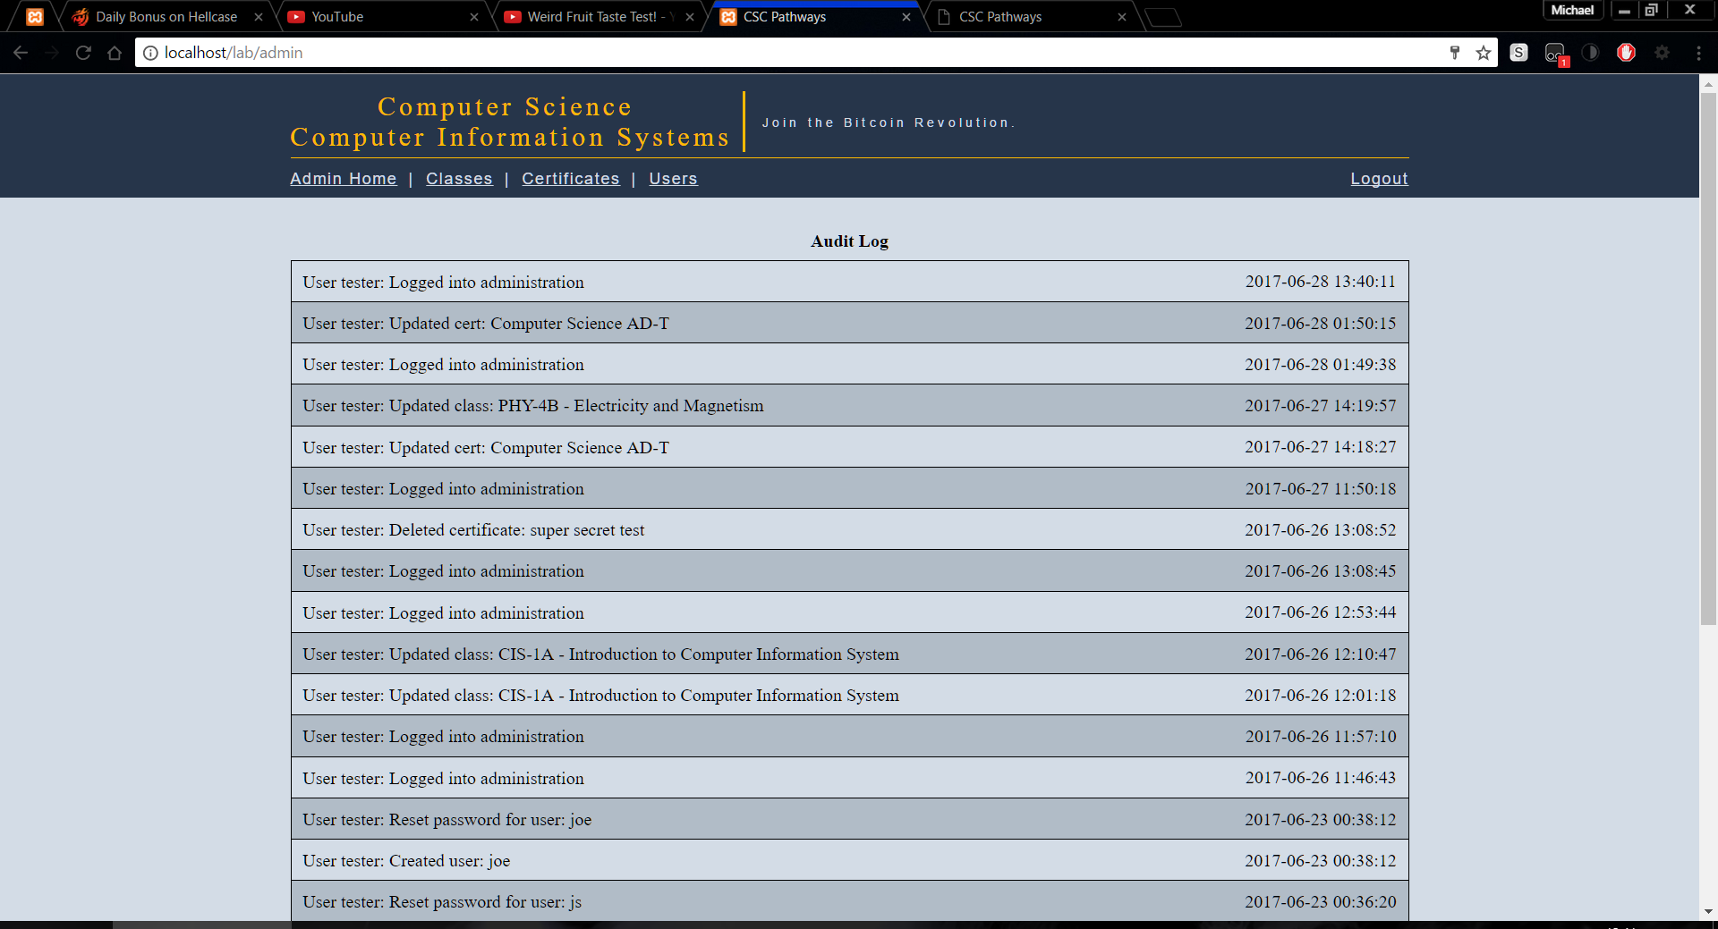

Figure Admin home page

If the user is inactive for longer than 10 minutes the website will log you out. If you try to reload a page after 10 minutes you will be redirected to a 404 error and will have to go to <http://cscpathways.us/login> to log back into the administrative side of the site.

### Problems logging in

There are two problems that could occur while trying to log in. You enter your password or username incorrectly (Figure 8) or your account has been set to inactive by an administrator (Figure 9). If your account has been deactivated you can ask your administrator to reactivate you. If you have forgotten your username or password you can ask an administrator to recover your password.

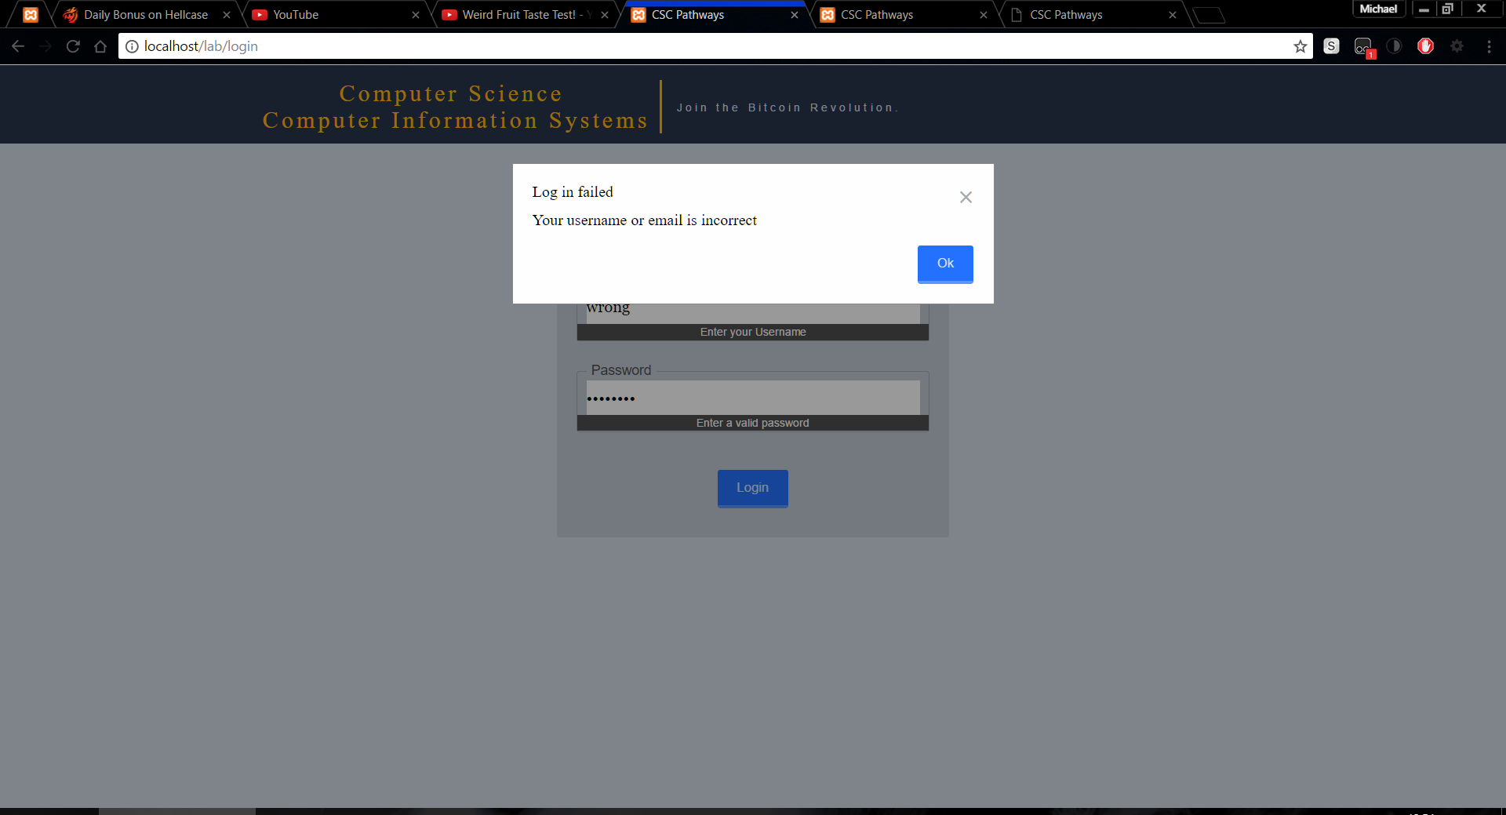

Figure Incorrect username or password on log in page

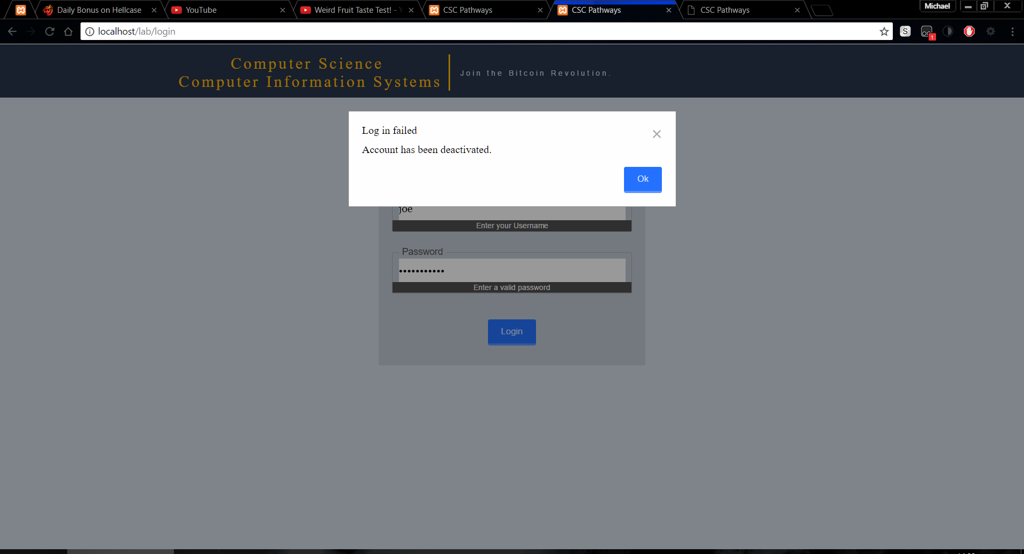

Figure Deactivated user in log in page

### Recovering a forgotten password

After requesting a password recovery from an administrator, they will send you a link that looks something like this <http://cscpathways.us/users/resetPassword&token=eQevERDvb1RGCiu>. From this page, you will have to enter your username.

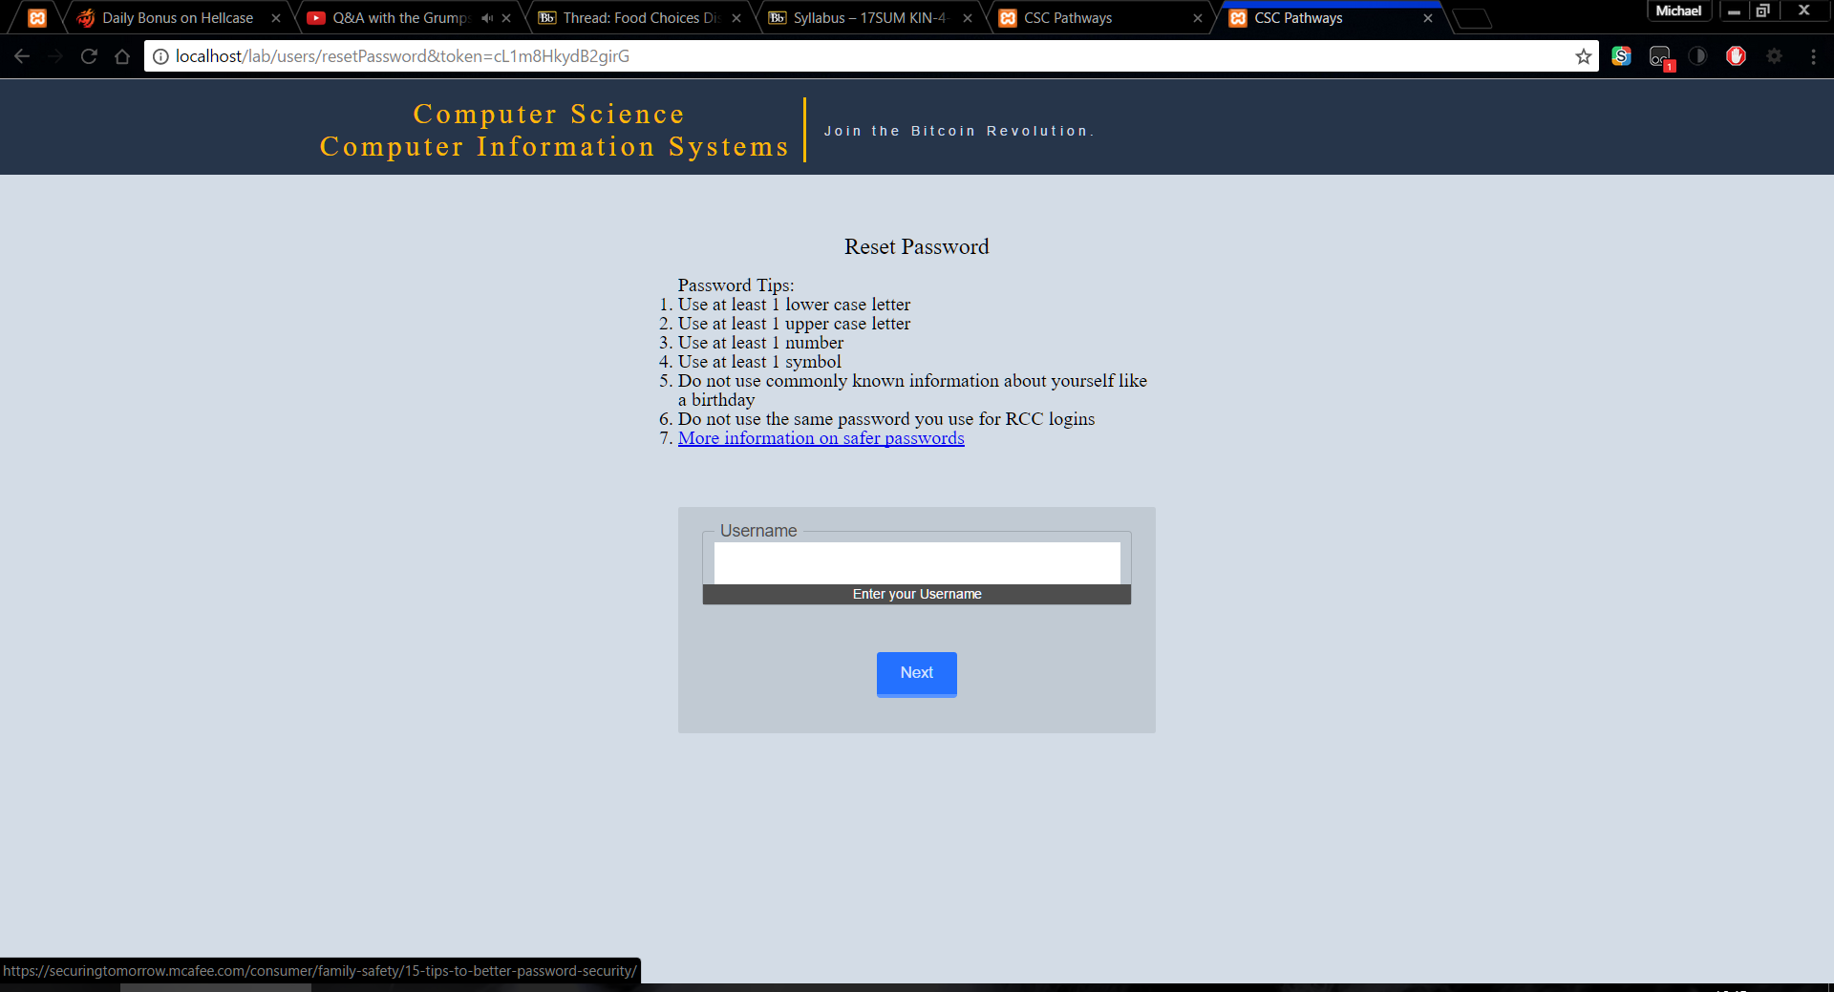

Figure Reset password form asking for username

Once your username and token are authorized, it will then prompt you to enter your new password. This password must have at least one uppercase letter, lowercase letter, number, and symbol to be valid. Once you provide a valid password you will need to repeat the password right below.

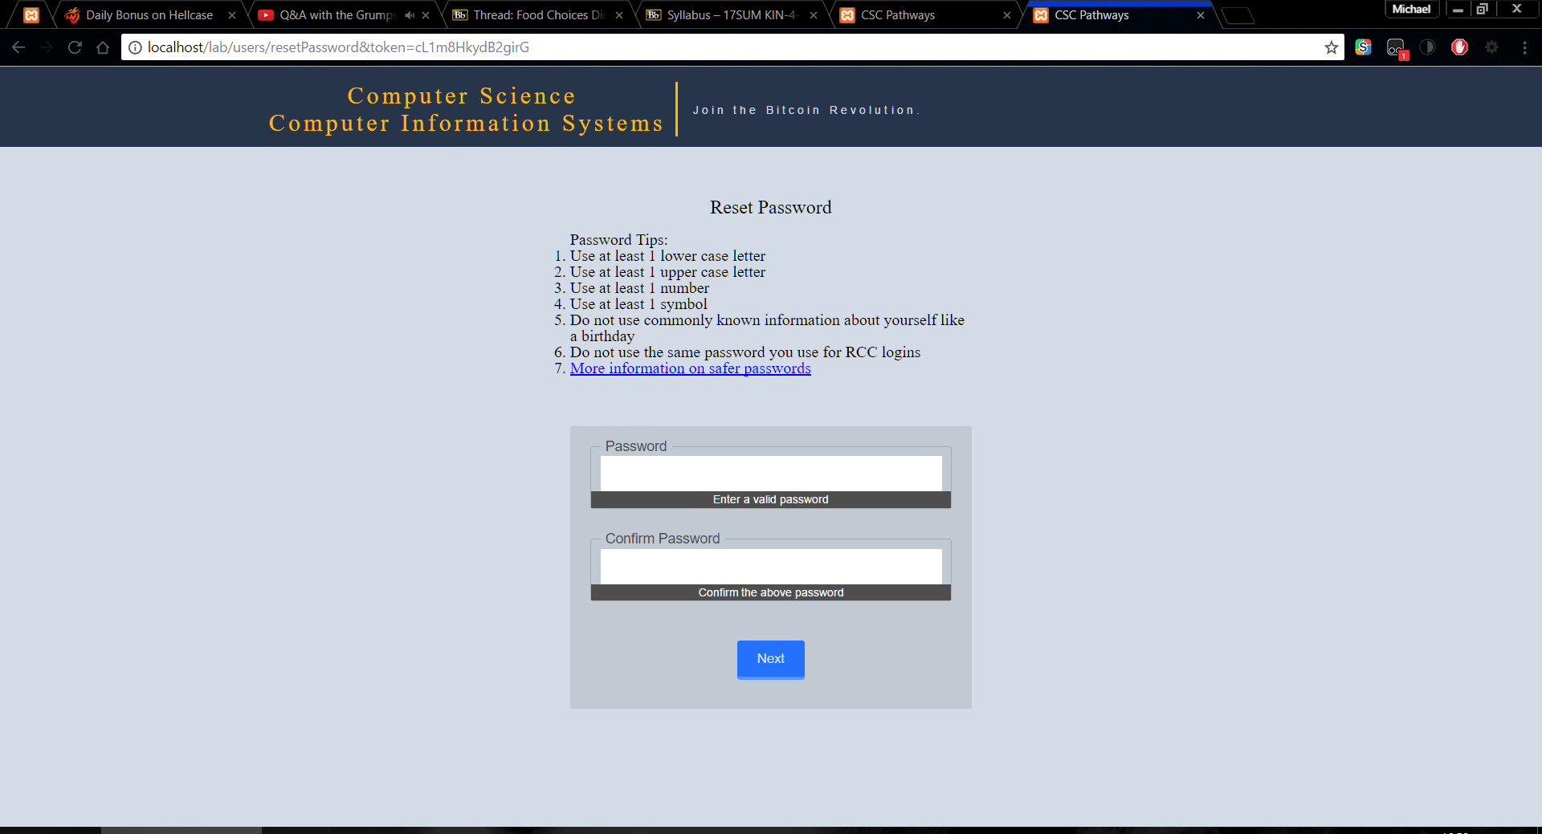

Figure Reset password form asking for new password

After you have reset your password you will then be redirected to the log in page from there you can log in normally with your new password.

# Managing Classes

All the classes that appear in the class information box can be edited through the administrative side of the site. Managing classes can be accessed by the link tilted classes under the orange title. Here are the editable areas for a class as seen from the user homepage

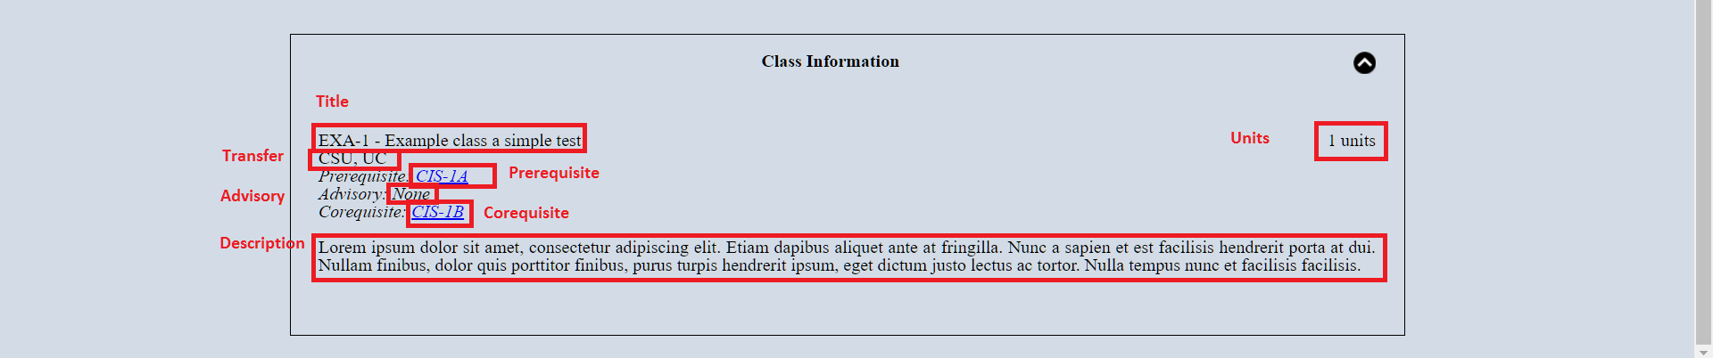

Figure Showing the editable areas for a class

## Creating classes

To create a class, in the manage classes page, scroll down to the bottom of the page, and click the blue Create Class button

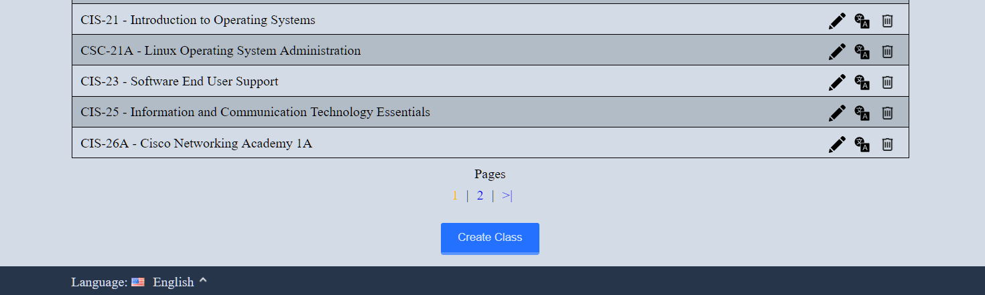

Figure Create class button

That button will open in a window popup called a modal. Inside this modal is a form with all the inputs each class can have

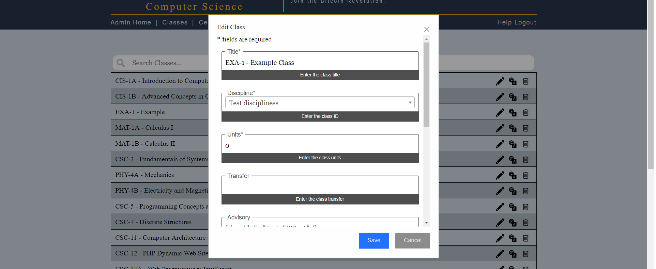

Figure Create class form

There are four required fields in this form they are title, discipline, units, and description. These four fields must have a value and units can only be a number. All other fields are optional and can be left blank. Now to explain each of the fields

### Fields within the create class

#### Title

Title is the class’s title for example CIS-1A – intro to computers. This title must match this pattern three letters (CIS) dash then some number (CIS-1) and optional a letter followed by a space dash space and then a title (CIS-1A - title). This field is required.

#### Discipline

The discipline that this class belongs to. A class can only have one discipline.

#### Units

Units is the number of units the class has. It can only be a number and the page should prevent you from doing anything but a number. This field is required.

#### Transfer

Transfer is any equivalent class code to a UC or a CSU. For example, UC, CSU (C-ID ITIS 120). This field is optional.

#### Adviosry, Prerequisite, Corequisite

Advisory, Prerequisite, Corequisite are classes that are advised to have taken prior to this class, classes you must take prior to this class, and classes that you need to take concurrently or prior to this class. Note that all three of these fields have a blue link to add class. If you want the class to be clickable on the user side of the website you need to use the add class link to properly link classes. Upon clicking the blue add class link a new modal will display. This modal will give you a dropdown of classes to pick from. Once you select the class click the add button.

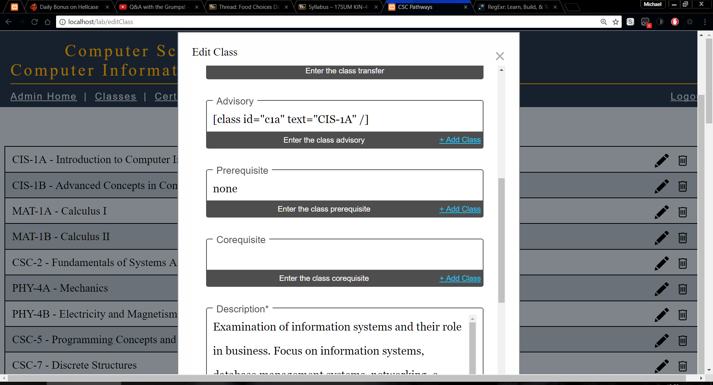

Figure Showing the add class link in the create class form

After adding a class, you will see in Figure 15 that the text “[class id="c1a" text="CIS-1A" /]” has been added. This code will make a link with whatever text is inside of the quotes in text=”Cis-1A” if you wanted to add a * to make a note you would edit the text inside the quotes of text to text=”Cis-1A*”. Along with adding a class you can also add plain text as seen in the prerequisite field in Figure 15. These fields are optional.

#### Description

Description is where the class’s description is added this field will grow as you type. This field is required.

When you have filled in all the fields that are required and any optional fields you can click on save. It will then confirm that it has

### Possible problems creating a class

Fields are glowing red and no error modal was displayed as shown in Figure 16. This is because the field is a required field and it was left blank

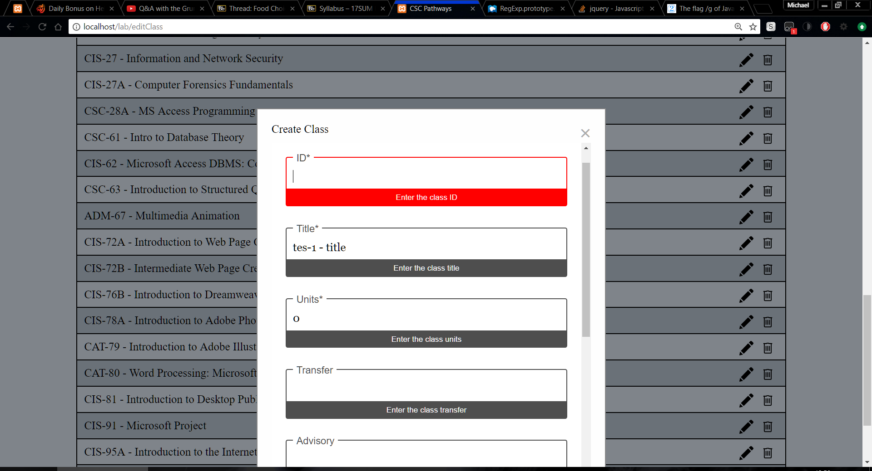

Figure Displaying an error of glowing red fields

## Editing classes

Editing classes can be done from the classes link under the logo. Here you should see a listing of every class, at the far right of each class there is a pencil, globalization icon, and a trashcan icon. Click the pencil to edit the class.

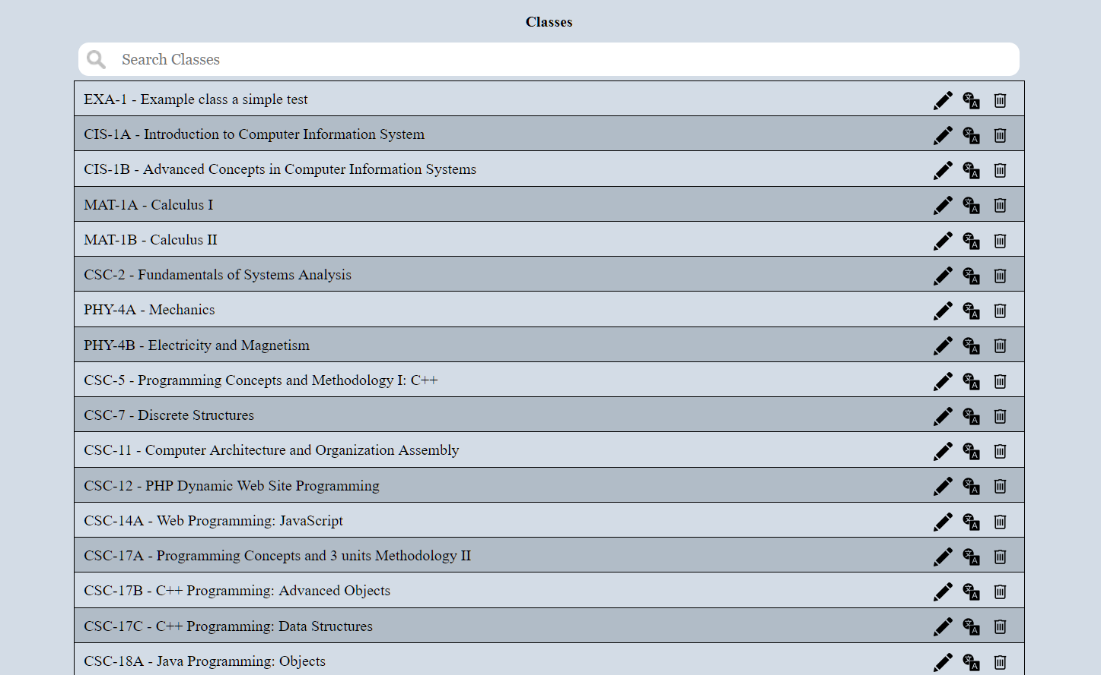

Figure Listing of classes showing the edit, globalization, trashcan icon

Editing the class is the exact same as creating a class with the exception that you cannot change the ID. For more information on the fields review the create class section here.

## Editing Classes in Different Languages

Editing a class in a different language can be done from the classes link under the logo. Here you should see a listing of every class, at the far right of each class there is a pencil, globalization icon, and a trashcan icon as seen in Figure 18. Click the globalization icon to edit the class in a different language. Upon clicking the globalization icon, a new modal will appear and ask which language you want to edit in.

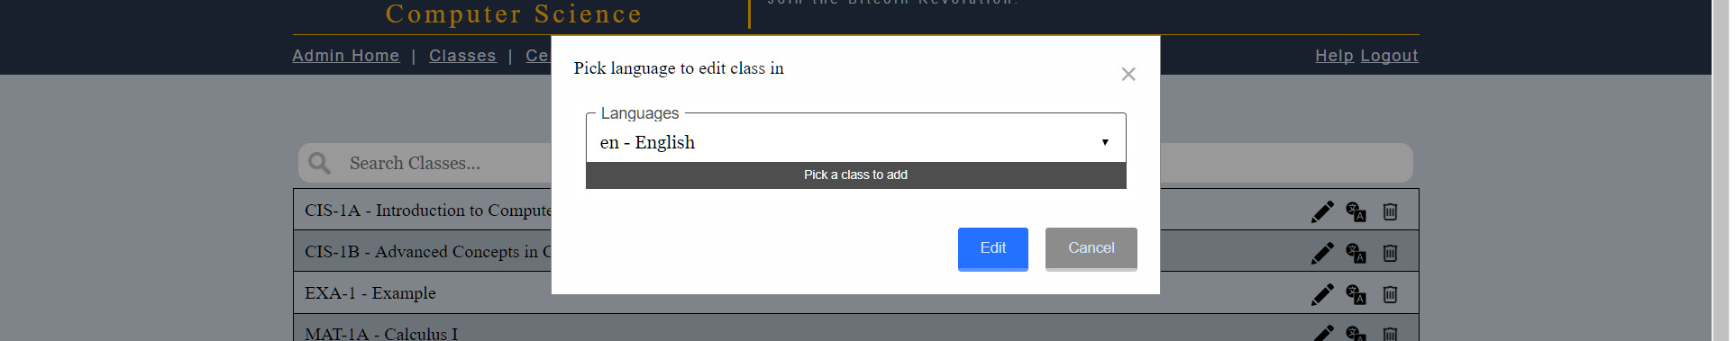

Figure Pick a language modal for globalization

After picking the language you want to edit in you will be editing the class like you did when you only had one language, which is also the same as creating a class. More information on creating classes can be read here

## Deleting classes

Deleting classes can be done from the classes link under the logo. Here you should see a listing of every class, at the far right of each class there is a pencil and a trashcan icon. Click the trashcan to delete the class. Refer to Figure 17. The website will ask you if you are sure since once this is done it cannot be un-done.

# Managing Certificates

All the Certificates that appear in the certification information box and in the three boxes at the top of the page can be edited through the administrative side of the site. Managing certificates can be accessed by the link tilted certificates under the orange title. Below is a picture of all the editable areas for a certificate highlighted in red and the field names

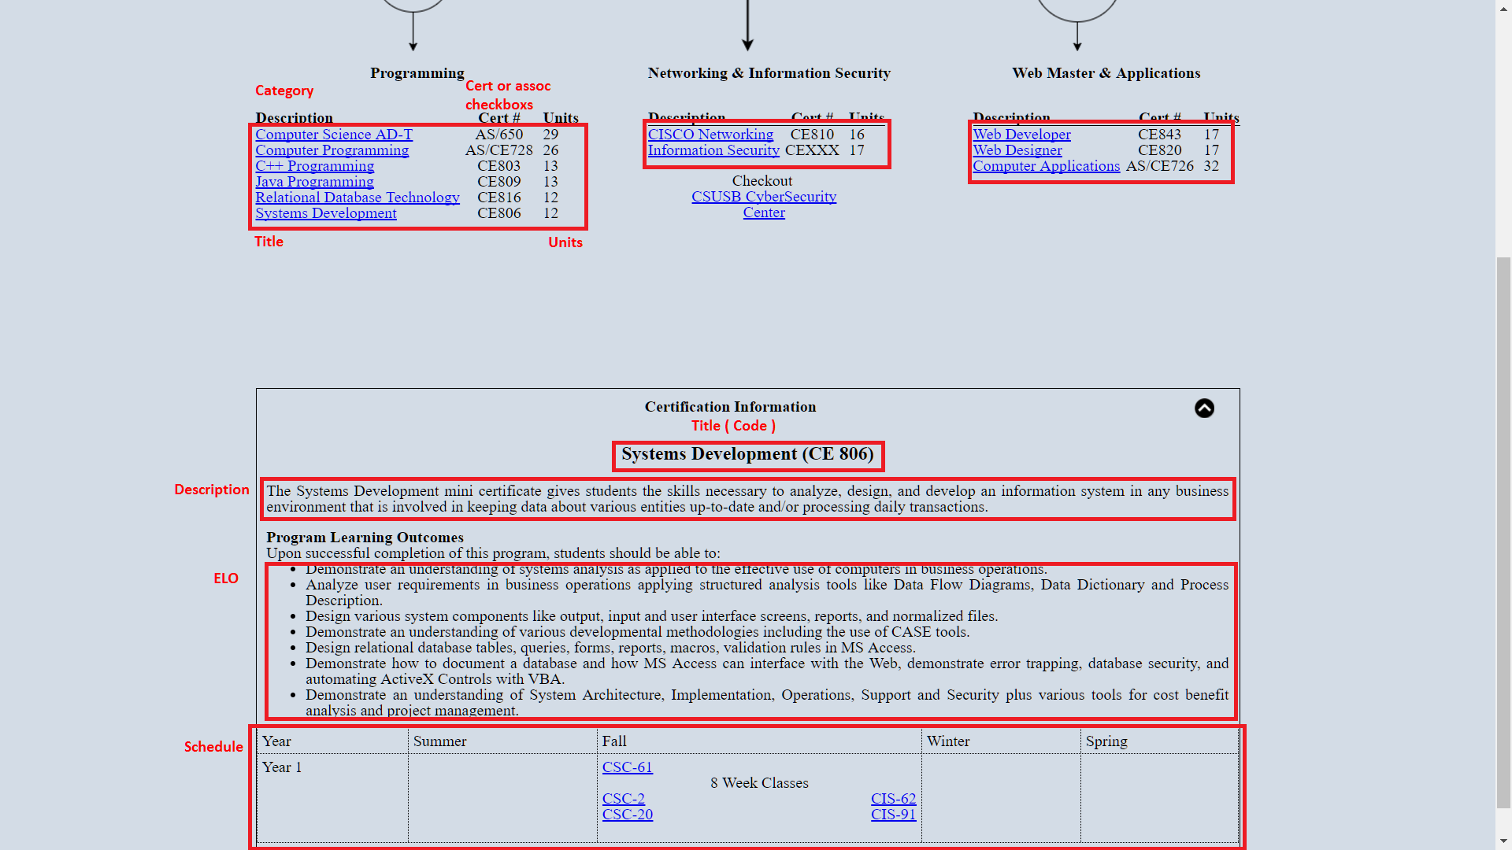

Figure Showing all the editable areas of a certificate

## Creating certificates

To create a certificate in the manage certificate page, scroll down to the bottom of the page, and click the blue create certificate button

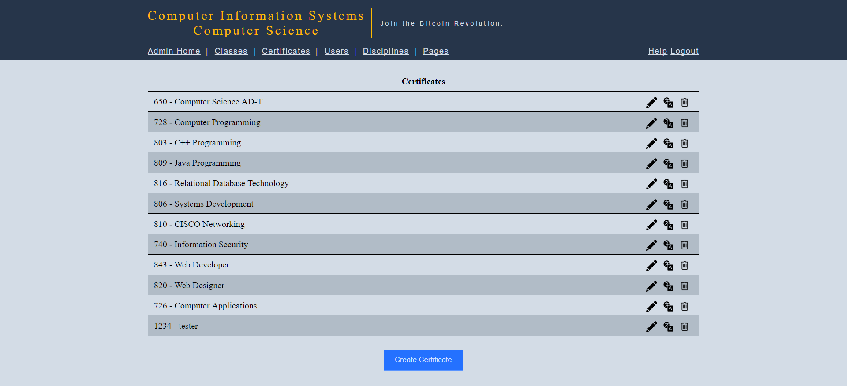

Figure Showing the create certificate button

After clicking the create certificate button you will then be redirected to a different page to edit this, instead of a modal like the classes. You will arrive at a page that looks like this. This page contains all the editable fields for every certificate

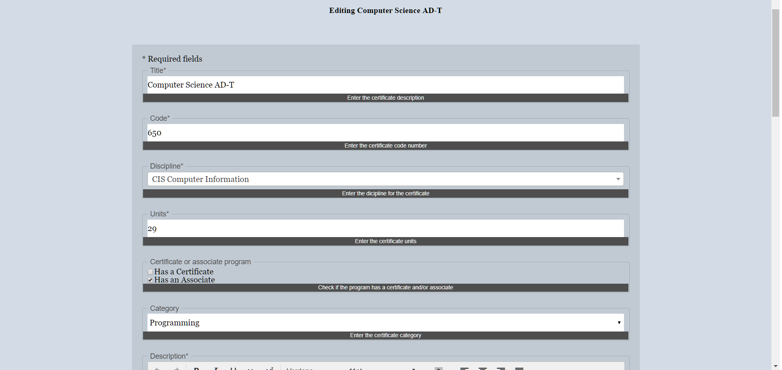

Figure Illustrating the certificate edit form

There are seven required fields in this form they are title, code, discipline, units, description, expected learning outcomes (ELO), schedule. These seven fields must have a value and units can only be a number. All other fields are optional and can be left blank. Now to explain each of the fields

### Fields within the create certificate

#### Title

The title is the certificate’s name for example “Computer Programming”

#### Code

The code is a three-digit number that the certificate is identified by. For example, Computer Programming’s certificate code is 728.

#### Discipline

This is what discipline this certificate belongs to. A certificate can only belong to one discipline.

#### Units

The units field is the number of units needed to take, to receive the certificate. For example, Computer Programming’s certificate units is 26.

#### Certificate or Associate program

The certificate or associate program consists of two checkboxes. These checkboxes determine whether this certificate is an associate degree and/or a certificate. On the user homepage, this will change how the code is displayed. If you only check the certificate checkbox it would look like CE728. If you were to check the associate instead of certificate it would look like AS728. If you checked both checkboxes it would look like AS/CE728.

#### Category

The category is there to place this certificate on the homepage. There are three categories which are for the three areas under the flowchart on the user homepage. These categories are: programming, networking, and web master. This field will default to programming if not set.

#### Description

The description is the first field that allows rich text. Meaning that you get an advanced text editor that allows for various style changes. The description is the description of the certificate. For example, Computer Programming’s certificate description is “This program focuses on the general writing and implementation of generic and customized programs…”

#### Expected learning outcome (ELO)

The ELO is a list of expected learning outcomes for the certificate. To create a list in the editor you will want to click on the button that is enclosed in the red box in Figure 21.

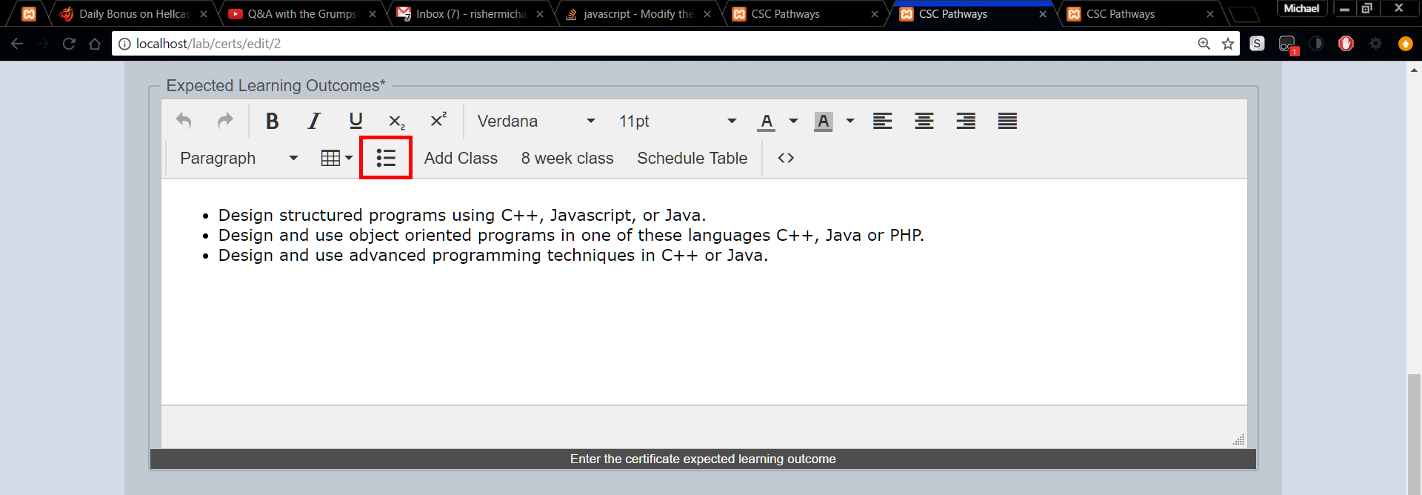

Figure Depicting the icon to create a list

#### Schedule

The schedule is the outline of classes you need to take and when to take them. This is the most complicated field to edit. I will walk you through it here. First off you want to click on Schedule Table which you can see in the enclosed red box in Figure 22

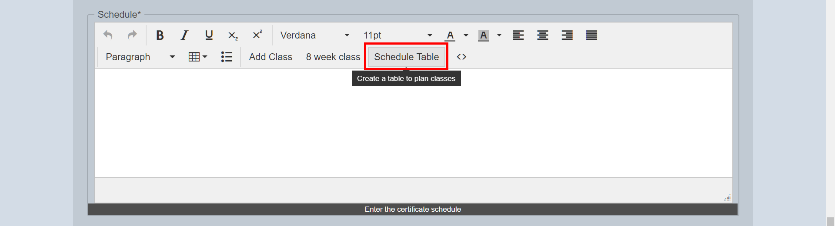

Figure Showing the schedule table

After you click the Schedule Table button you can see a small table with all four semesters and a blank row with only year 1. Let’s create a class in the summer row for year 1. You want to remove any spaces in the blank spot. Then click on the Add Class button which you can see enclosed in a red box in Figure 23

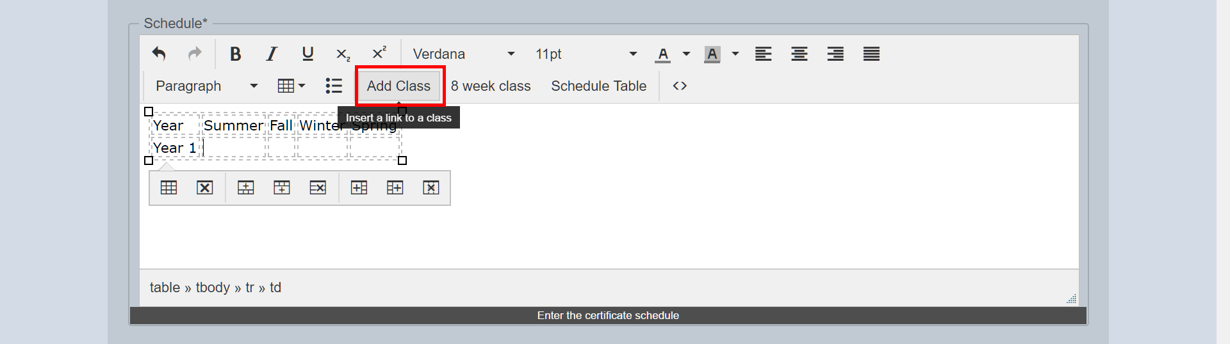

Figure Depicting the Add Class button

After clicking the Add Class button a modal should popup with a dropdown of classes. Pick the class you want and click the add button at the bottom of the modal.

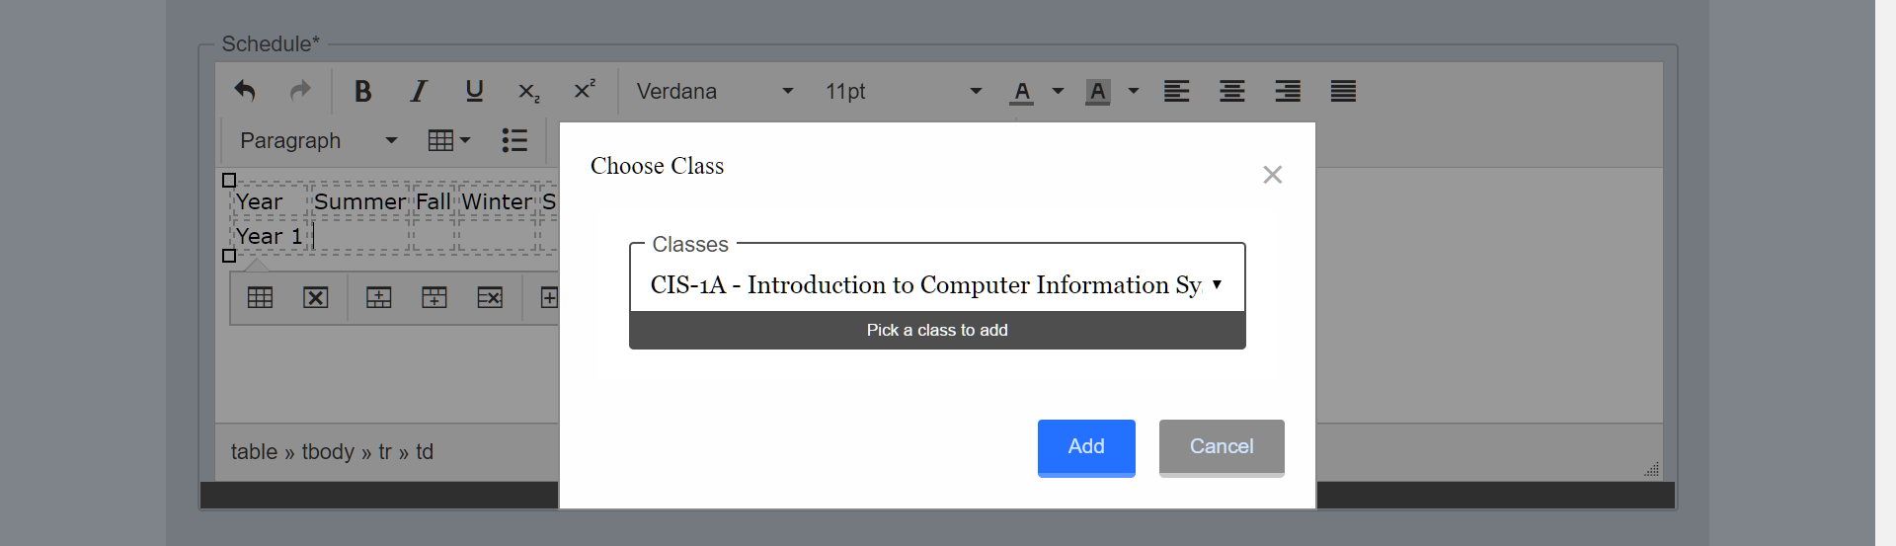

Figure The Add Class button displaying a choose class modal

After clicking add you should see some text appeared where you were typing in the editor. It should look something like this [class id="11" text="CIS-1A" /]. That text will create a link on the user homepage to go to that class. If you wanted to add a superscript to that link you could go inside the quote where text= and after the A and type your superscript letter or number. Then highlight that letter or number and click the superscript button which looks like X2. To add an 8-week class, go to the end of the current line a make a new line. Then hit the 8 Week Class button which you can see enclosed in a red box in Figure 25

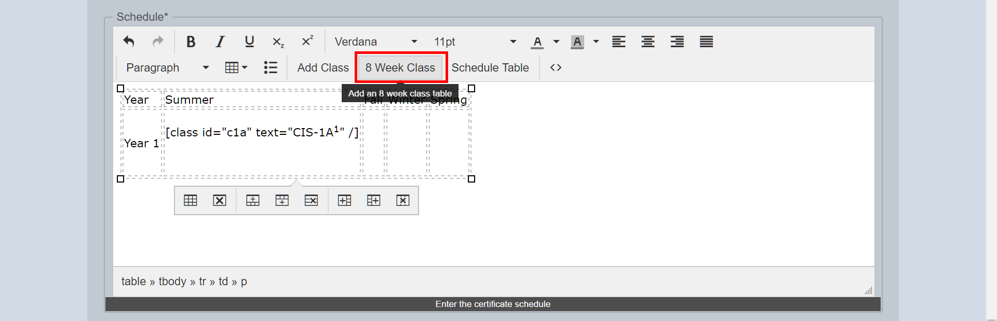

Figure Depicting the 8 Week Class button

After clicking the 8 Week Class button you will see that another table is now inside the cell you were editing. In this smaller table, there is two cells with the text class1 and class2. You can highlight that text and replace it with a class from the Add Class button.

#### Position in list

The position in the list is where this certificate should be listed on the user homepage for its category. The counting scheme starts at zero. Zero means it is the first item displayed. A value of one will be below the item which has a value of zero.

### Possible Errors

#### Fields glowing red

Fields are glowing red as shown in Figure 26. This is because the field is a required field and it was left blank.

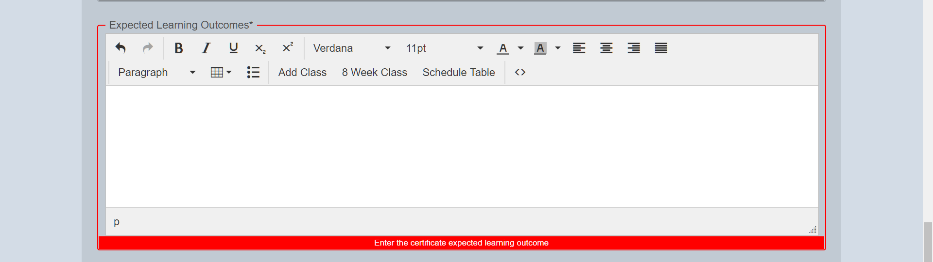

Figure Showing the glowing error

#### Table is to small on user homepage

If the table is too small on the user homepage which can be seen in Figure 27

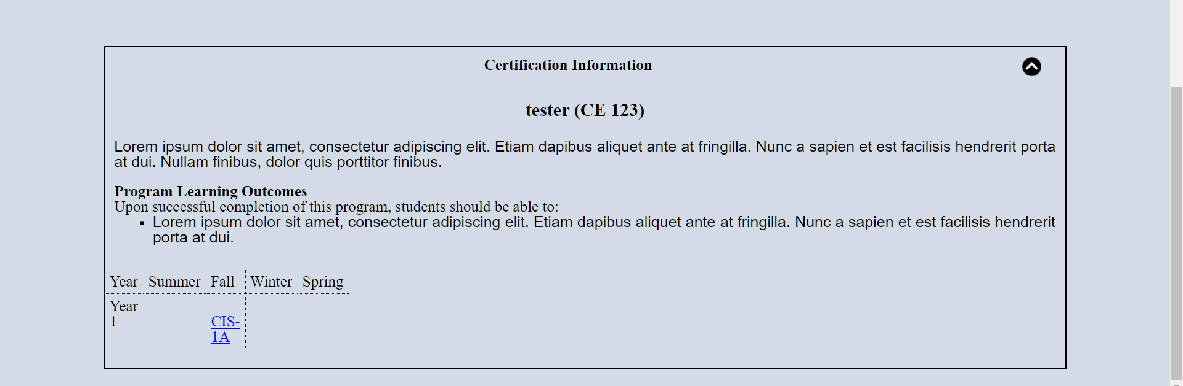

Figure Showing a table that is to small

To fix this edit the certificate and go to the schedule field. Click anywhere inside the table within the editor. A menu should appear within the editor. Click on the first button which should be table properties in this menu as seen in Figure 28

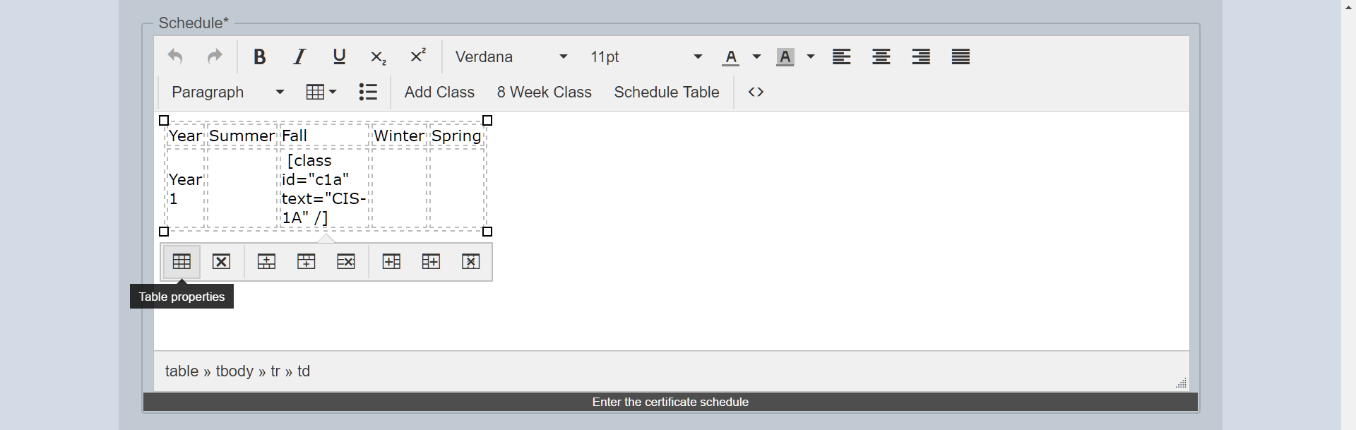

Figure Table menu showing the table properties

After clicking the table properties button, you will see a modal popup showing the width, height, and various other options. If the table is to small there is a number in the width or height fields which you can see in Figure 29.

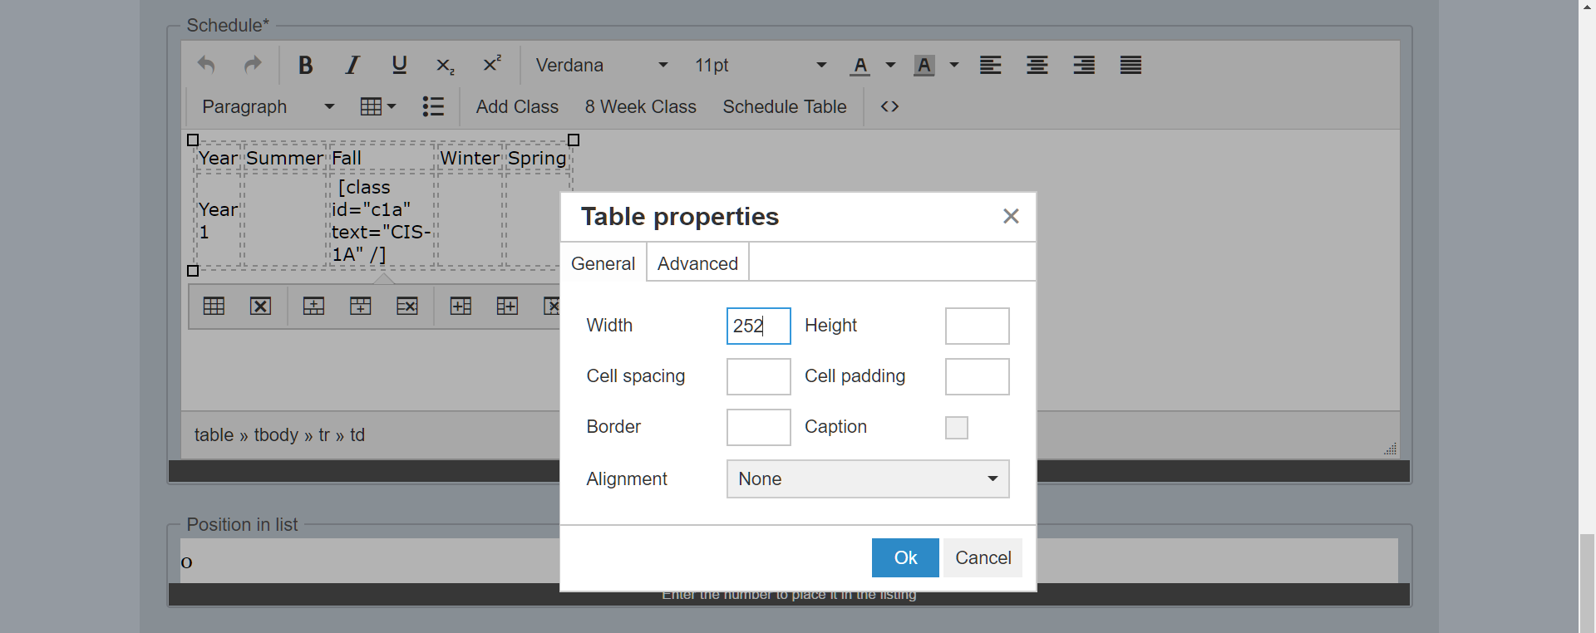

Figure Table properties modal

To fix this simply erase the number in either the width field or height field.

## Editing certificates

Editing certificates can be done from the certificates link under the logo. Here you should see a listing of every certificate, at the far right of each certificate there is a pencil, globalization icon, and a trashcan icon. Click the pencil to edit the certificate.

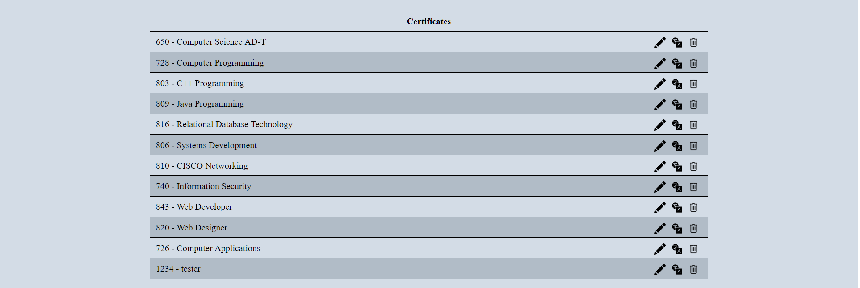

Figure Listing of certificates showing the edit and trashcan icon

Editing the certificate is the exact same as creating a certificate. For more information on the fields review the create certificate section here.

## Editing Certificates in Different Languages

Editing a certificate in a different language can be done from the certificate link under the logo. Here you should see a listing of every certificate, at the far right of each class there is a pencil, globalization icon, and a trashcan icon as seen in Figure 31. Click the globalization icon to edit the certificate in a different language. Upon clicking the globalization icon, a new modal will appear and ask which language you want to edit in.



After picking the language you want to edit in you will be editing the certificate like you did when you only had one language, which is also the same as creating a certificate. More information on creating certificates can be read here

## Deleting certificates

Deleting certificates can be done from the certificates link under the logo. Here you should see a listing of every certificate, at the far right of each certificate there is a pencil and a trashcan icon. Click the trashcan to edit the certificate. Refer to Figure 30. The website will ask you if you are sure since once this is done it cannot be un-done.

# Managing Users

Only users that have access to view users can see other users in the user link under the orange title.

## Creating users

If you have access to edit users, you can create a user by scrolling to the bottom of the mange user page and clicking the create user button. This will open a create user modal.

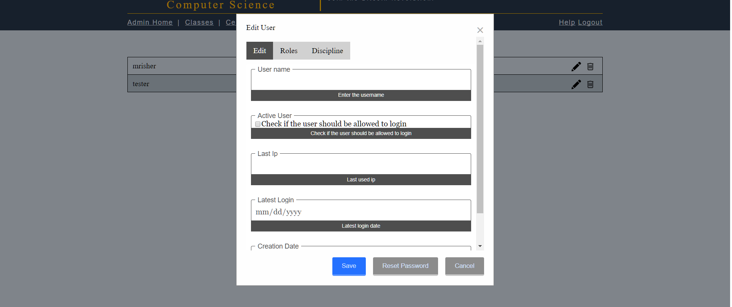

Figure The create user modal.

### Edit Tab

In this form, you need to fill out the username for the user. In the active user area, you need to check the checkbox if you want that user to be able to log in. Without it being checked that user will not be able to access the administrator side of the website. The field last IP will have the last IP the user logged in at. The latest login is the date at which the user last logged in. Finally, the creation date is the date at which the user was created. All three of these fields will always be un-editable.

### Roles Tab

In this form is where a user gets their different permissions to do preform actions on the website. By default, all newly created users are given roles of view certificates globally and view classes globally. If they do not have this role they may encounter a problem on the user side of the website not being able to see classes or certificates. This can be seen in Figure 33.

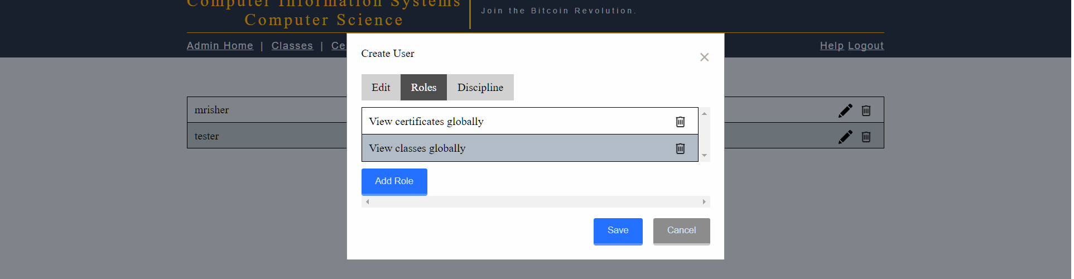

Figure Roles tab for create users

To add a role to a user simply click the add role button, this will open a new modal with a dropdown list of roles to pick from grouped by areas (i.e. class roles, certificate roles, user roles). If you can not see the button to add role you do not have permission to add roles to users.

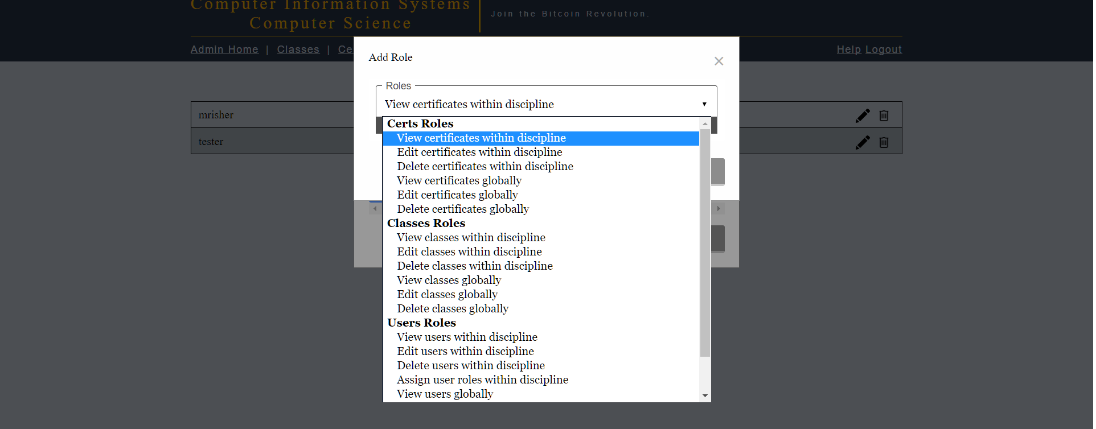

Figure Add roles modal showing the dropdown of possible roles

Once you have picked a role for the user click the add button to add it. Below is a listing of all the roles and an explanation of each role

|  |  |
| --- | --- |
| Role | Explanation |
| Certificates Roles | |
| View certificates within discipline | User can view the certificates within their discipline |
| Edit certificates within discipline | User can edit the certificates within their discipline |
| Delete certificates within discipline | User can delete the certificates within their discipline |
| View certificates globally | User can view all certificates |
| Edit certificates globally | User can edit all certificates |
| Delete certificates globally | User can delete all certificates |
| Class Roles | |
| View classes within discipline | User can view the classes within their discipline |
| Edit classes within discipline | User can edit the classes within their discipline |
| Delete classes within discipline | User can delete the classes within their discipline |
| View classes globally | User can view all classes |
| Edit classes globally | User can edit all classes |
| Delete classes globally | User can delete all classes |
| User Roles | |
| View users within discipline | User can view the users within their discipline |
| Edit users within discipline | User can edit the users within their discipline |
| Delete users within discipline | User can delete the users within their discipline |
| Assign user roles within discipline | User can assign roles and disciplines to users within their discipline |
| View users globally | User can view all users |
| Edit users globally | User can edit all users |
| Delete users globally | User can delete all users |
| Assign user roles globally | User can assign roles and disciplines to all users |
| Special Roles | |
| Data manager | Can create disciplines and pages |

### Discipline Tab

This form is where a user can set which discipline a user belongs in. A user can belong to multiple disciplines if they need to. By default, a new user belongs to no disciplines. Clicking the add discipline button will have a new modal appear with a dropdown list that is searchable.

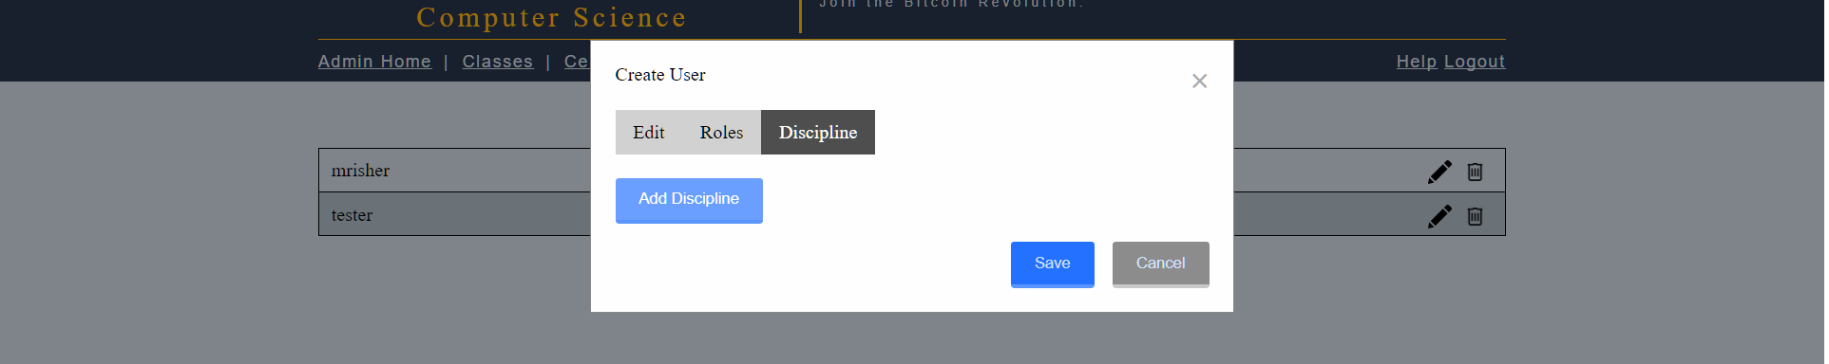

Figure Modal to add discipline for users

### Saving Your Created User

Once you have finished creating the users you can click the save button. A modal will then appear displaying a link. This link is important as it allows the user you created to set their password. If you clicked Ok without copying this link you can go to Recovering a password for a user to make them a new link.

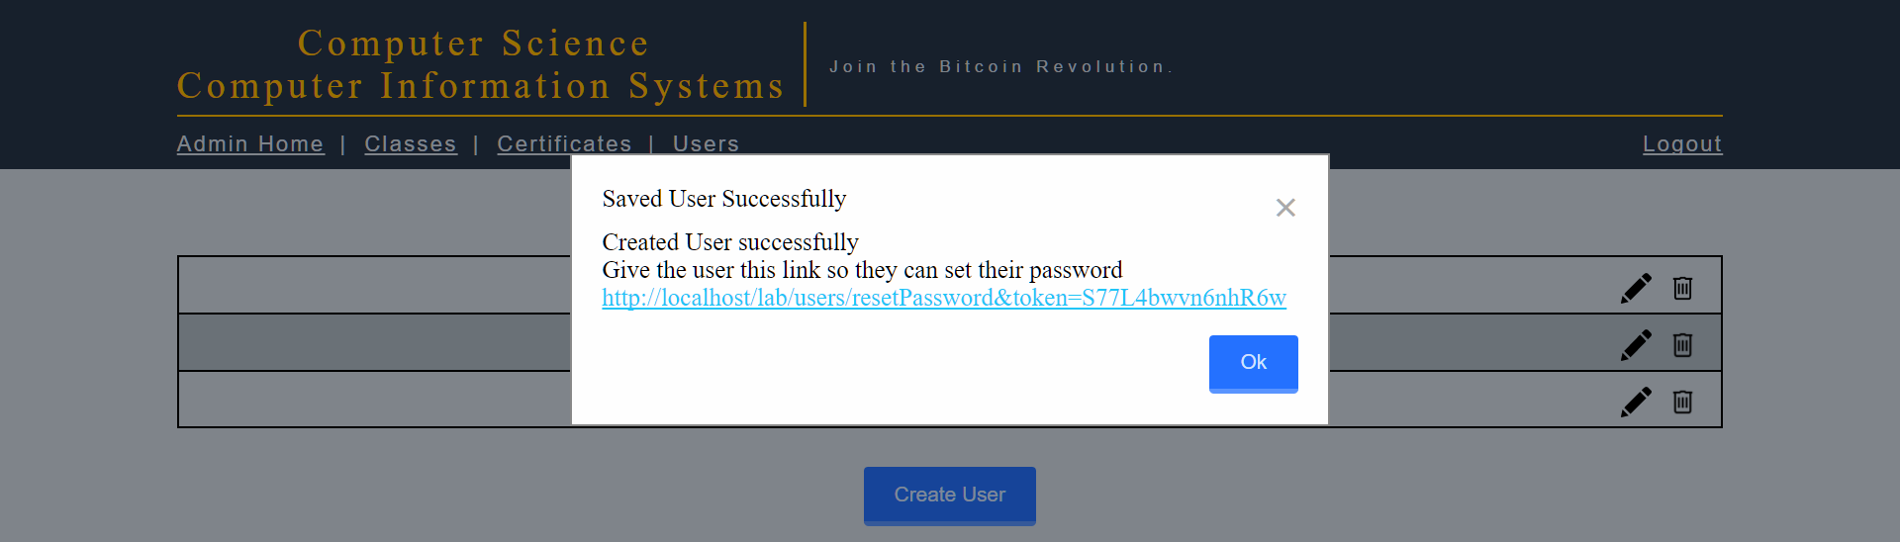

Figure After creating a new user, a recover password link appears. Usernames have been omitted in the background.

After clicking the save button a modal will pop up with a link this link is very important. This link is what you give the user to set their password. If you clicked Ok without copying this link you can go to Recovering a password for a user to make them a new link.

## Editing a user

Editing users can be done from the users link under the logo if the user is an administrator. Here you should see a listing of every user, at the far right of each user there is a pencil and a trashcan icon. Click the pencil to edit the user.

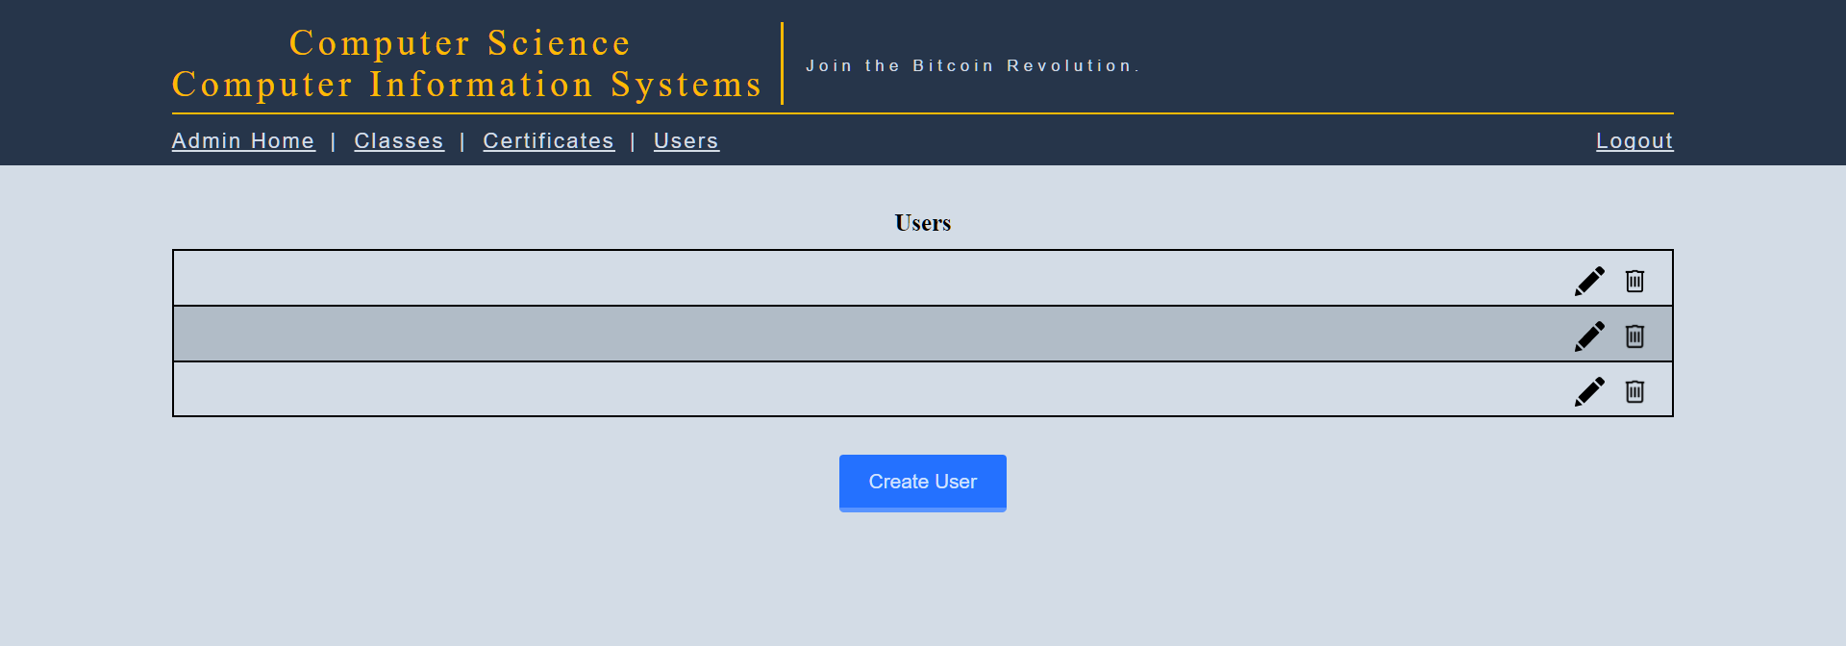

Figure The user listing with the edit and delete icons. Usernames have been omitted but would show.

Editing the user is the exact same as creating a user except there is a recover password button. For more information, how to create a user see the Creating user section.

## Recovering a password for a user

Since the administrator cannot interact in any way with the user’s passwords a recover password link must be created if a user forgets or loses their password. To recover a password the administrator must edit the user and click the Reset Password button at the bottom.

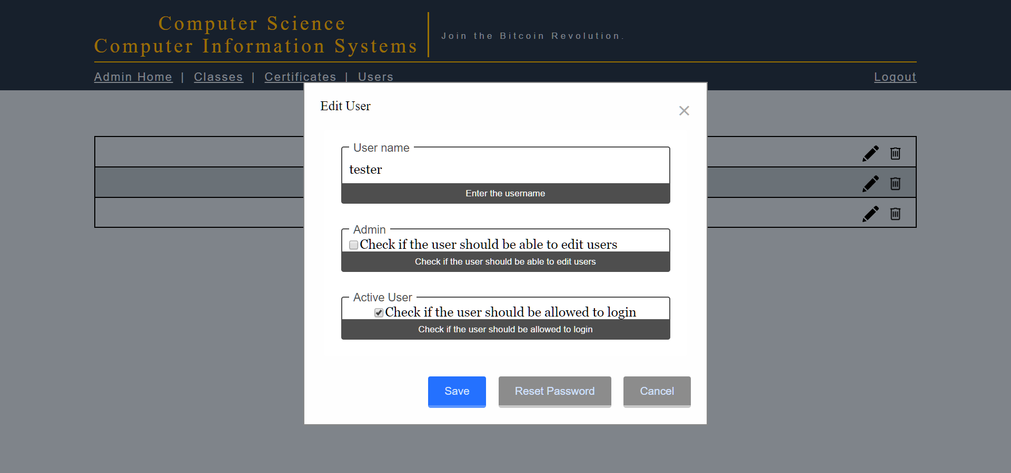

Figure Reset password button shown on the bottom. Usernames omitted in the background.

After clicking the reset password, you will see this modal. Make sure to copy the blue link and give that to the user.

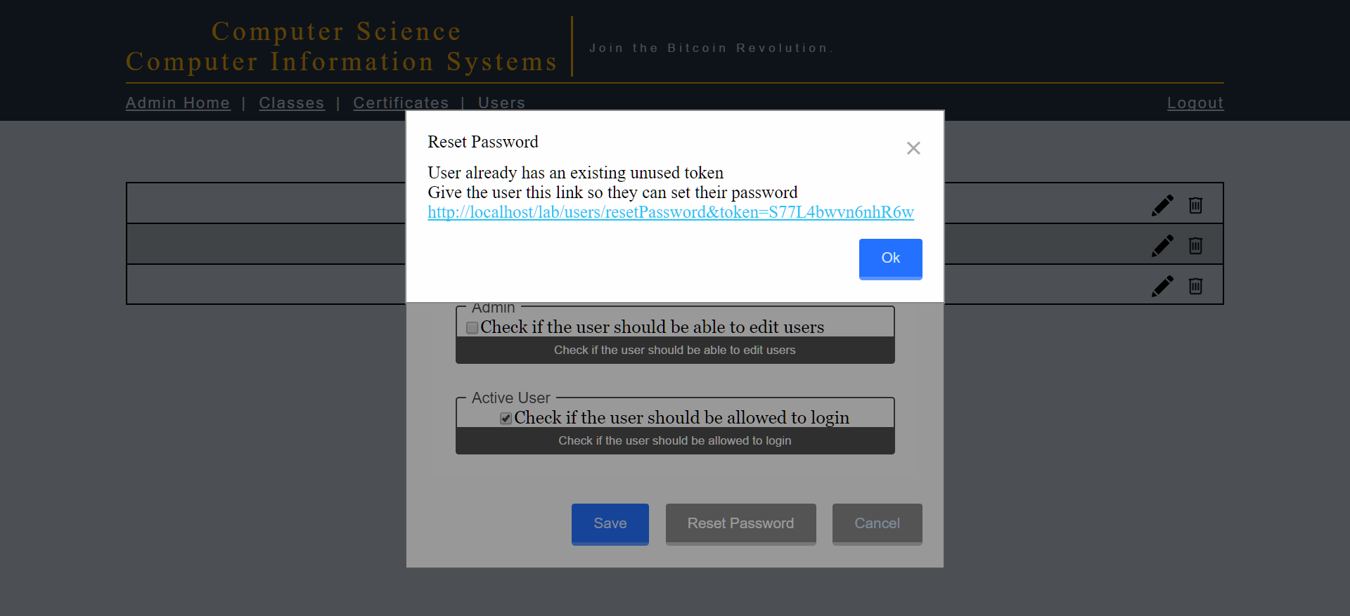

Figure Showing the recovering password for a user

If a link already exists for the user it will use that one instead of creating a new link as it did here.

## Deleting a user

Deleting users can be done from the users link under the logo. Here you should see a listing of every user, at the far right of each user there is a pencil and a trashcan icon. Click the trashcan to delete the user. Refer to Figure 32. The website will ask you if you are sure since once this is done it cannot be un-done.